NEW DESIGN ENQUIRY FORM
We welcome textile design enquiries of all kinds, whether you are looking for a brand new product to be manufactured or you are interested in redesigning an existing product you already have.
Please complete this form with as much detail as you know. The more information you can provide us with, the more accurate a quote we can provide for you and the faster we can provide it.

Company name and website

Product description / purpose

Material(s) and colour(s)

Any required fixtures and fittings – straps, zips, fastenings etc.

Quantity to be quoted

Any required print and positioning on product

Any required logo and positioning on product | If required, please attach to your email as an EPS or AI (CS6 or lower) file

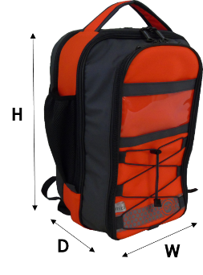
Images
Please attach to your email any photos or drawings that you may have.

Please include the dimensions as shown, taking note of any additional dimensions e.g. a front pocket.

